**Practical No: 5**

Page| 11

## Aim: Write a program to apply various enhancements on images using image derivatives by implementing Gradient and Laplacian operations.

## Gradient: The following code block shows how to compute the gradient with the convolution kernels shown previously, with the gray-scale chess image as input. It also plots how the image pixel values and x_component of the gradient vector changes with the y coordinates for the very first row in the image(x=0):

**Program Code: A**

import numpy as np

from scipy import signal, misc, ndimage

from skimage import filters, feature, img_as_float

from skimage.io import imread

from skimage.color import rgb2gray

from PIL import Image, ImageFilter

import matplotlib.pylab as pylab

def plot_image(image, title):

pylab.imshow(image), pylab.title(title, size=20), pylab.axis('off')

ker_x = [[-1, 1]]

ker_y = [[-1], [1]]

im = rgb2gray(imread('../images/chess.png'))

im_x = signal.convolve2d(im, ker_x, mode='same')

im_y = signal.convolve2d(im, ker_y, mode='same')

im_mag = np.sqrt(im_x**2 + im_y**2)

im_dir = np.arctan(im_y/im_x)

pylab.gray()

pylab.figure(figsize=(30,20))

pylab.subplot(231), plot_image(im, 'original'), pylab.subplot(232),

plot_image(im_x, 'grad_x')

pylab.subplot(233), plot_image(im_y, 'grad_y'), pylab.subplot(234),

plot_image(im_mag, '||grad||')

pylab.subplot(235), plot_image(im_dir, r'$\theta$'), pylab.subplot(236)

pylab.plot(range(im.shape[1]), im[0,:], 'b-', label=r'$f(x,y)|_{x=0}$', linewidth=5)

pylab.plot(range(im.shape[1]), im_x[0,:], 'r-', label=r'$grad_x (f(x,y))|_{x=0}$')

pylab.title(r'$grad_x (f(x,y))|_{x=0}$', size=30)

pylab.legend(prop={'size': 20}

pylab.show()

**output:**

Page| 12

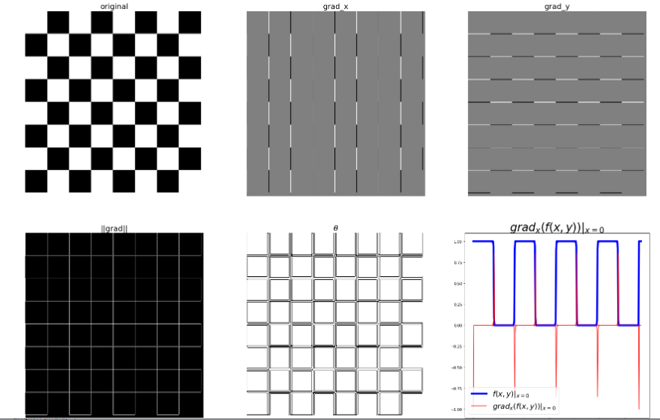

**Program Code B: Laplacian operations.**

ker_laplacian **=** [[0,**-**1,0],[**-**1, 4, **-**1],[0,**-**1,0]]

im **=** rgb2gray(imread('../images/chess.png'))

im1 **=** np**.**clip(signal**.**convolve2d(im, ker_laplacian, mode**=**'same'),0,1)

pylab**.**gray()

pylab**.**figure(figsize**=**(20,10))

pylab**.**subplot(121), plot_image(im, 'original')

pylab**.**subplot(122), plot_image(im1, 'laplacian convolved')

pylab**.**show()

**output:**

